Number Of Steps to Reduce A Number To Zero
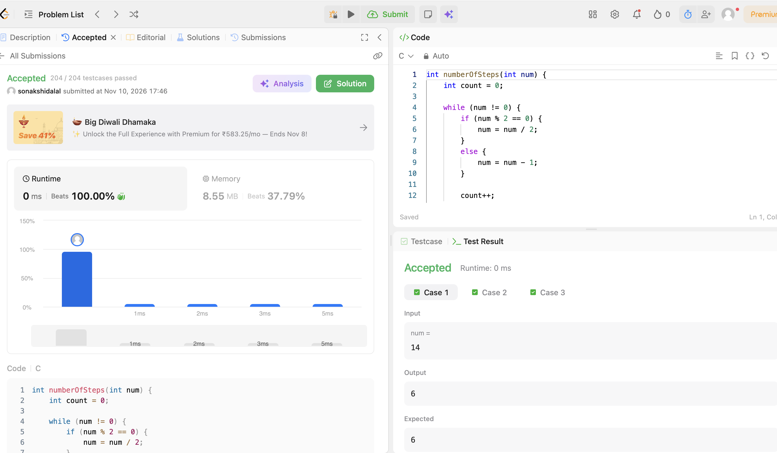
CODE:
int numberOfSteps(int num) {
int count = 0;

while (num != 0) {
if (num % 2 == 0) {
num = num / 2;
}
else {
num = num - 1;
}
count++;
}
return count;
}

